MATH STATION #7: I can:

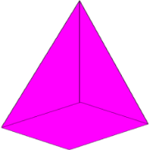
Identify geometric figures that contain squares: (circle correct shapes below)

Identify geometric figures with curved edges or lines: (circle correct shapes below)

Identify solid geometric figures: (circle correct shapes below)

Name: ____________________________________________________ Date: __________________

