## What Am I? Chart

**Name: Date:**

|  |  |  |  |  |  |
| --- | --- | --- | --- | --- | --- |
| **Geometric solid** | **Name** | **Number**  **of faces** | **Shape(s) of faces** | **Number**  **of edges** | **Number**  **of vertices** |
| MC900048285[1] |  |  |  |  |  |
|  |  |  |  |  |  |
|  |  |  |  |  |  |
|  |  |  |  |  |  |
|  |  |  |  |  |  |
|  |  |  |  |  |  |

## What Am I? Matching Cards

**Cylinder**

**Sphere**

**Cone**

**Cube**

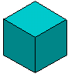

**Rectangular prism**

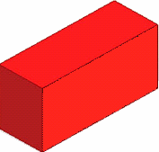

**Square**

**pyramid**

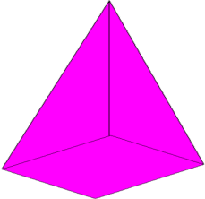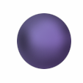

**I have 1 circle and 1 curved surface. My curved surface bends to make a sharp point. I don’t have edges.**

**What am I?**

**I have 2 congruent circles that are joined by a curved surface. I don’t have any edges or vertices. I can roll.**

**What am I?**

**I am a solid figure that is perfectly round. I don’t have flat faces and I don’t have edges.**

**What am I?**

**I have 6 square faces, 12 edges, and 8 vertices. All my edges are the same length.**

**What am I?**

**I have 6 flat faces, 12 edges, and 8 vertices. All my edges are NOT the same length.**

**What am I?**

**I have 5 faces. One of my faces is square. The other 4 faces are triangular and come together at a vertex.**

**What am I?**