MATH STATION #9: I can:

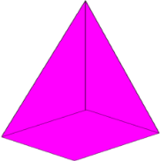
Identify geometric figures that have 12 edges: (circle correct shapes below)

Identify geometric figures with more than one vertex: (circle correct shapes below)

Identify solid geometric figures with all equal angles: (circle correct shapes below)

Name: ____________________________________________________ Date: __________________

