## Marshmallow Chart

**Name: Date:**

Directions: Look carefully at each figures at the attached worksheets. Try to replicate each shape using marshmallows and toothpicks. Record the number of toothpicks and marshmallows that you used to build each shape.

|  |  |  |
| --- | --- | --- |
| **FIGURE** | **Number of Toothpicks** | **Number of Marshmallows** |
| circle |  |  |
| rectangle |  |  |
| square |  |  |
| triangle |  |  |
| sphere |  |  |
| cube |  |  |
| rectangular prism |  |  |
| cone |  |  |
| cylinder |  |  |
| square pyramid |  |  |

1. What did the toothpicks represent on the plane (2-D) shapes?
2. What did the toothpicks represent on the solid (3-D) shapes?
3. What did the marshmallows represent on the plane (2-D) shapes?
4. What did the marshmallows represent on the solid (3-D) shapes?
5. Which shapes could you not build? Why?

## Plane Geometric Figures

**Rectangle**

**Square**

**Triangle**

**Cylinder**

**Sphere**

**Cone**

**Cube**

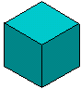

**Rectangular prism**

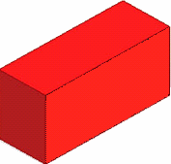

**Square**

**pyramid**

