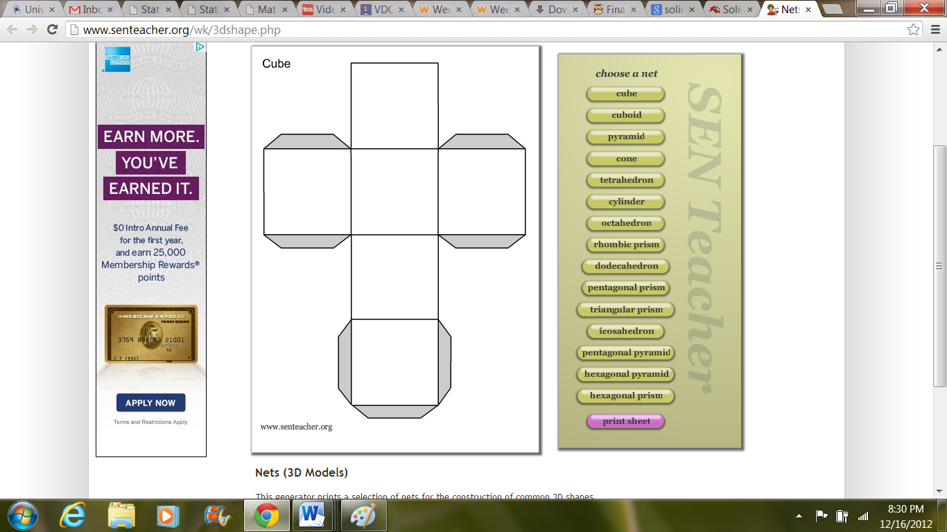

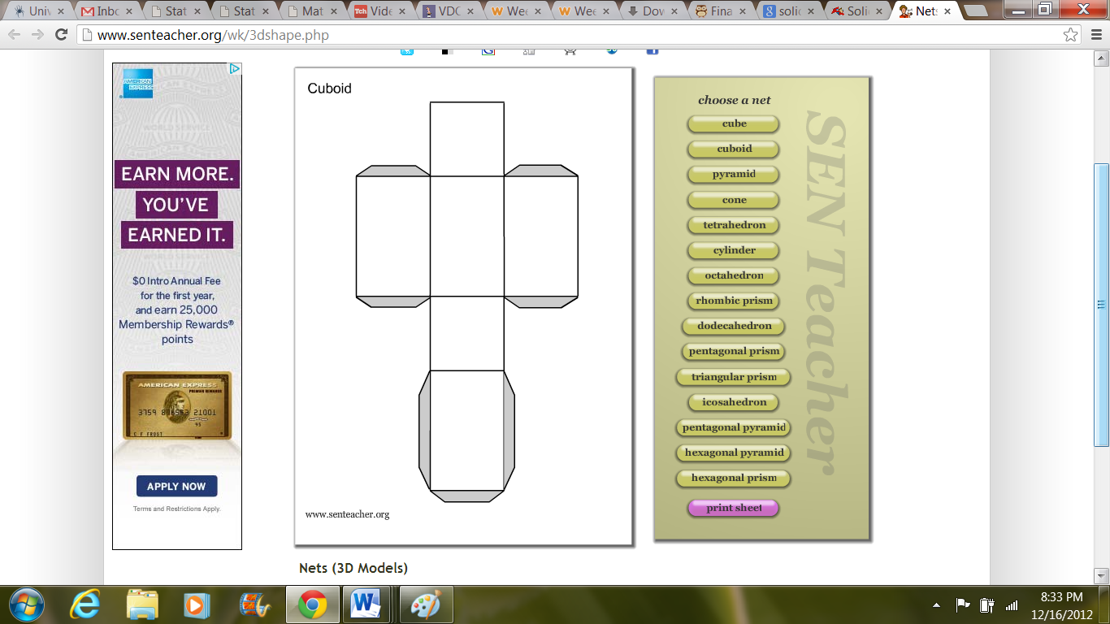

Rectangular Prism

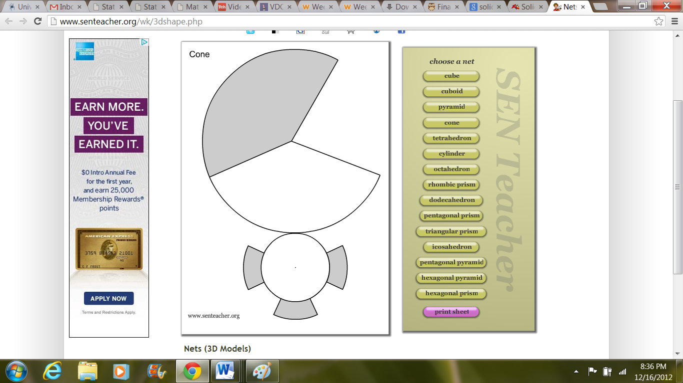

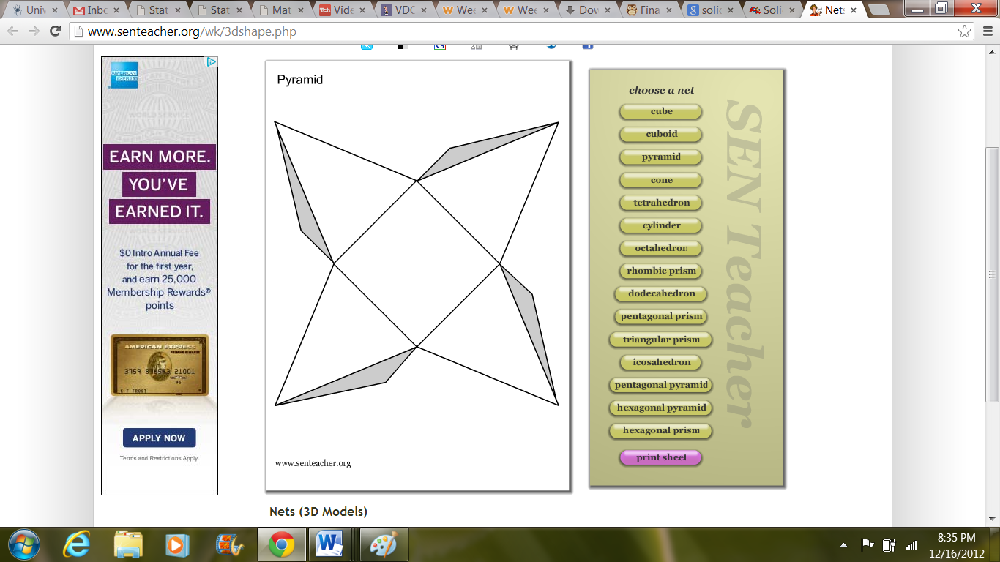

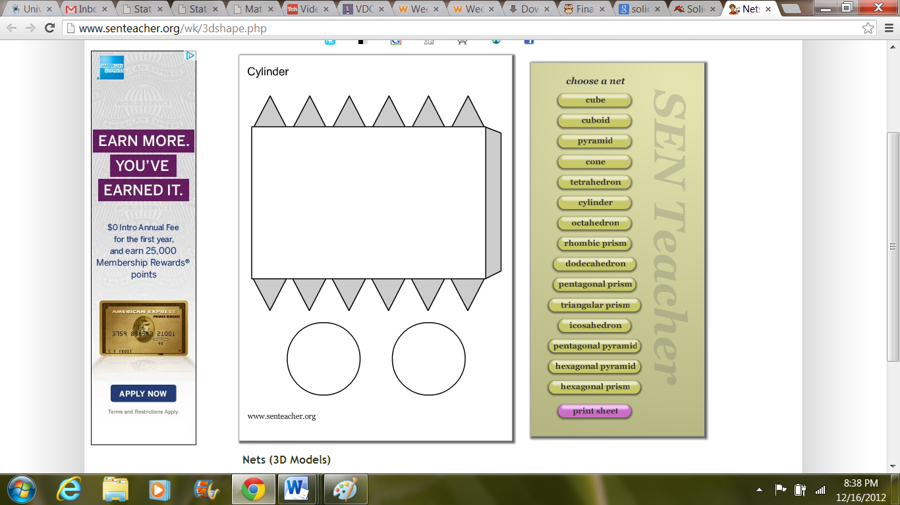

**Directions:** Cut out the figures around the outside of each shape. Fold the cut-outs along the lines so that only the white portions show. Fold the gray tabs underneath with glue to hold the formed shapes together.